
Introduction to DOSBox
Lab 4

Computer Organization and Assembly Language

Student Name | Muhammad Hassan Khalid
Registration # | 21L-5692
Instructor | Hazoor Ahmad
Class | CS3
Section | A1, A2, D1, D2
Semester | Fall 2022

Fast School of Computing
FAST-NU, Lahore, Pakistan

Activity 1

Assembly Language Code
[[org 0x100]

mov ax, 0x5692
mov bx, ax

and ax, 0x5555
and bx, 0xAAAA

shl ax, 1
shr bx, 1

or ax, bx

mov ax, 0x4C00
int 0x21

Debugging Screenshots
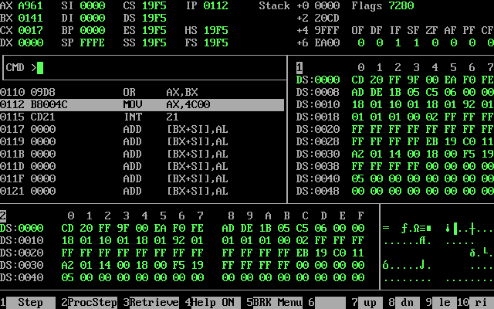

Activity 2

Assembly Language Code
[org 0x100]

mov ax, 0x5692
mov bx, ax

and ax, 0x3333
and bx, 0xCCCC

shl ax, 2
shr bx, 2

or ax, bx

mov ax, 0x4C00
int 0x21

Debugging Screenshots
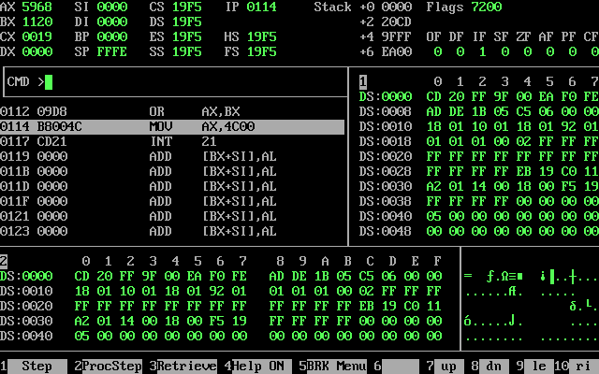

Activity 3

Assembly Language Code
[org 0x100]

mov ax, 0x5692
mov bx, ax

and ax, 0x0F0F
and bx, 0xF0F0

shl ax, 4
shr bx, 4

or ax, bx

mov ax, 0x4C00
int 0x21

Debugging Screenshots
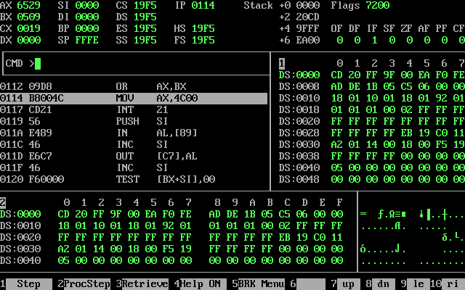

Activity 4

Assembly Language Code
[org 0x100]

mov ax, 0x5692
mov bx, ax
mov cx, ax

or ax, bx
xor cx, 0x1BCD

and ax, cx
mov [f], ax

mov ax, 0x4C00
int 0x21

f : dw 0

Debugging Screenshots
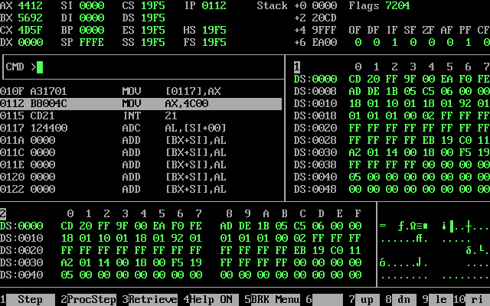

Activity 5

Assembly Language Code
[[org 0x100]

mov ax, 0x5692
mov bx, ax

mov word[a], ax
mov word[b], bx
mov cx, 16

l1:
shr word[b], 1
jnc skip
mov dx, [a]
add word[f], dx
mov dx, [a+2]
adc word[f+2], dx

skip:
shl word[a], 1
rcl word[a+2], 1

loop l1
add word[f], bx
adc word[f+2], ax

mov ax, 0x4c00
int 0x21

a: dw 0
b: dw 0
f: dd 0

Debugging Screenshots
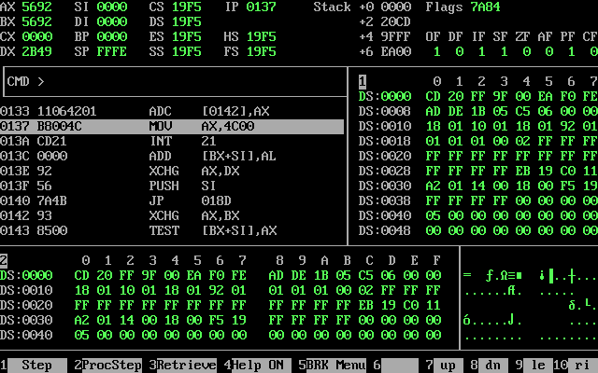

Activity 6

Assembly Language Code
[org 0x100]

mov ax, 0x5692
mov bx, ax

and ax, 0x5555
and bx, 0xAAAA

shl ax, 1
shr bx, 1

or ax, bx

mov ax, 0x4C00
int 0x21

Debugging Screenshots


